Hindi Vidya Prachar Samiti’s
RAMNIRANJAN JHUNJHUNWALA COLLEGE OF ARTS, SCIENCE, AND COMMERCE
(EMPOWERED AUTONOMOUS)

Introduction to Supervised Learning



Name: Surajkumar Yadav
Roll no: 10302
Class: MSc. Data Science and Artificial Intelligence Part I


Ramniranjan Jhunjhunwala College
of Arts, Science and Commerce

Department of Data Science and Artificial Intelligence

CERTIFICATE

This is to certify Surajkumar Yadav of MSc. Data Science and Artificial Intelligence Roll No. 10302 has successfully completed the practical of Introduction to Supervised Learning during the Academic Year 2024-2025.
Date:

(Prof. Mujtaba Shaikh) External Examiner Prof-In-Charge

INDEX

Sr No. | Practical Name | Date
1 | Feature Engineering | -
1.1 | Data Imputation | 18/7/24
1.2 | Handling Categorical Variable | 18/7/24
1.3 | Feature Scaling | 19/7/24
1.4 | Feature Selection | 20/7/24
2 | Linear Regression | -
2.1 | Simple Linear Regression | 25/7/24
2.2 | Multiple Linear Regression | 27/7/24
2.3 | Polynomial Linear Regression | 27/7/24
3 | Regularization | -
3.1 | L1 – Lasso Regression | 1/8/24
3.2 | L2 – Ridge Regression | 1/8/24
4 | Classification | -
4.1 | Logistic Regression | 1/8/24
4.2 | Decision Tree | 8/8/24
4.3 | Random Forest | 8/8/24
4.4 | Naïve Bayes | 9/8/24

Practical 1
Feature Engineering

1.1 Data Imputation

Code:

import pandas as pd
import matplotlib.pyplot as plt
import seaborn as sns
df=pd.read_csv('/content/drive/MyDrive/supervisedlearning/datasets /titanic_toy.csv')
df.sample(5)
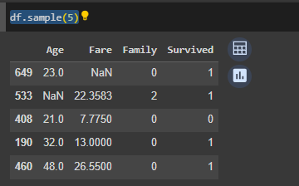

df.isnull().sum()
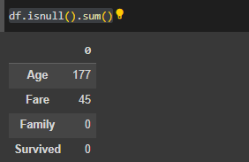

df.isnull().mean()*100
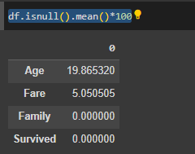

- finding mean median mode for age and fare column

age_mean= df['Age'].mean()
age_median=df['Age'].median()
age_mode=df['Age'].mode()

fare_mean=df['Fare'].mean()
fare_median=df['Fare'].median()
fare_mode=df['Fare'].mode()

m=[age_mean,age_median,age_mode,fare_mean,fare_median,fare_mode]
for i in m:
print(i)
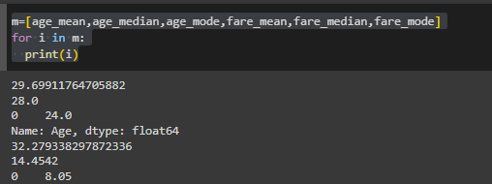

- Replacing null value

df['imputed_age_mean']=df['Age'].fillna(age_mean)
df['imputed_fare_mean']=df['Fare'].fillna(fare_mean)
df.sample(5)
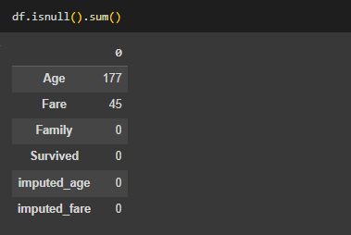

- using mean
df['Age'].plot(kind='kde',label='age before')
df['imputed_age_mean'].plot(kind='kde',label='age after mean')
plt.legend()

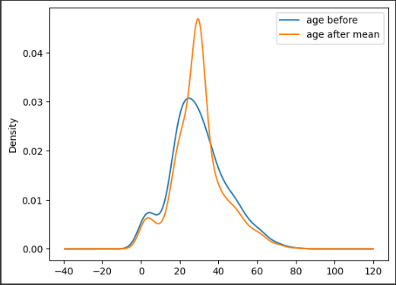

df['Fare'].plot(kind='kde',label='before mean ')
df['imputed_fare_mean'].plot(kind='kde',label='after mean ')
plt.legend()
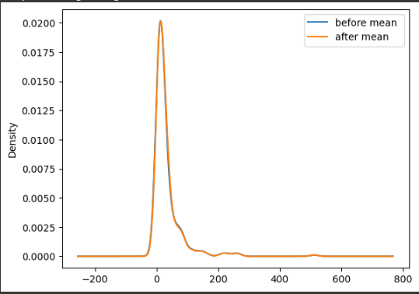

- using median
df['imputed_age_median']=df['Age'].fillna(age_median)
df['imputed_fare_median']=df['Fare'].fillna(fare_median)

df['Age'].plot(kind='kde',label='before median ')
df['imputed_age_median'].plot(kind='kde',label='after median ')
plt.legend()

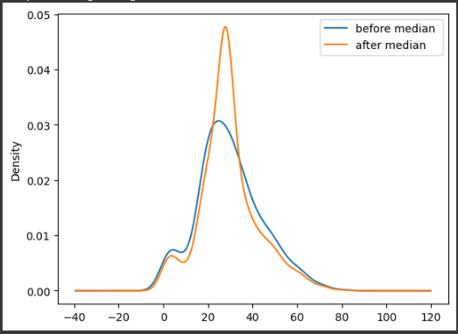

df['Fare'].plot(kind='kde',label='before median ')
df['imputed_fare_median'].plot(kind='kde',label='after median ')
plt.legend()
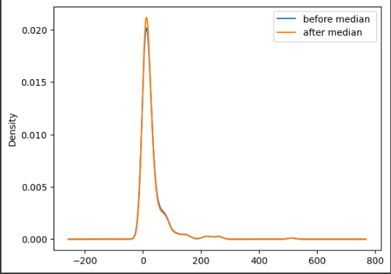

- using mode
df['imputed_age_mode']=df['Age'].fillna(age_mode)
df['imputed_fare_mode']=df['Fare'].fillna(fare_mode)

df['Age'].plot(kind='kde',label='before mode')
df['imputed_age_mode'].plot(kind='kde',label='after mode')
plt.legend()

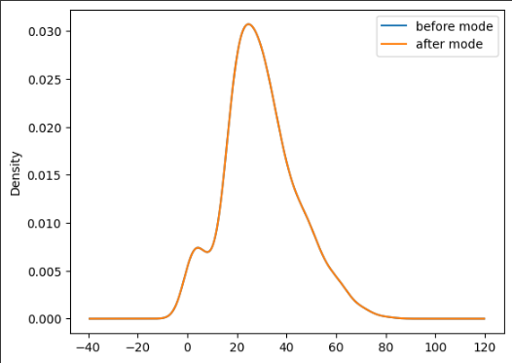

df['Fare'].plot(kind='kde',label='before mode')
df['imputed_fare_mode'].plot(kind='kde',label='after mode')
plt.legend()
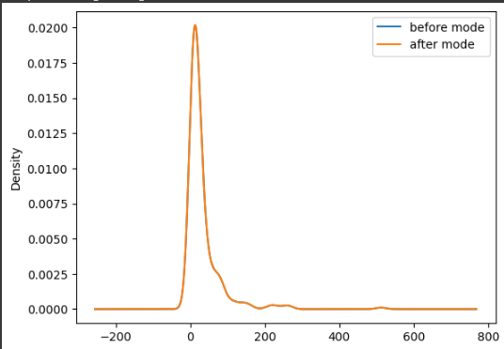

for age, we will choose the mode as it fits the perfect curve and for fare, we will choose either median or mode as it fits the curve

1.2 Handling Categorical Variable

import pandas as pd
from sklearn.preprocessing import LabelEncoder

data=pd.DataFrame({
'Name':['luffy','zoro','nami','zimbae','robin'],
'Roll no':[12,34,45,12,13],
'Gender':['M','M','F','M','F'],
'Marks':['good','poor','avg','excellent','poor']
})
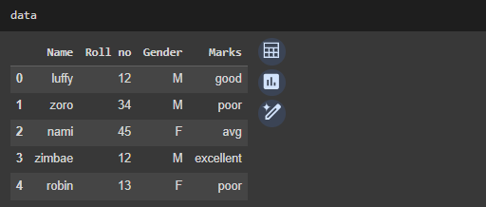

data['Gender'].unique()
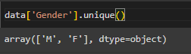

data['Gender'].value_counts()
data['Marks'].value_counts()
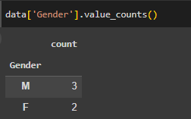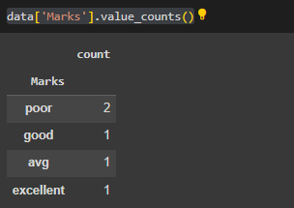

- using pandas to perform one hot encoding

pd.get_dummies(data,columns=['Gender','Marks'],dtype=int)
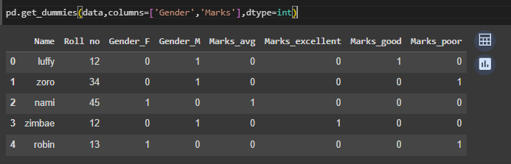

- using scikit-learn to perform one hot encoding

le= LabelEncoder()
datale=data
datale['Gender']=le.fit_transform(data['Gender'])
datale['Marks']=le.fit_transform(data['Marks'])

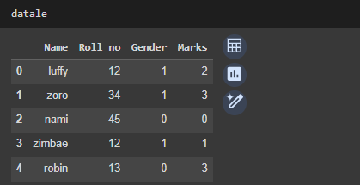

1.3 Feature Scaling

import pandas as pd
import matplotlib.pyplot as plt
from sklearn.metrics import confusion_matrix
from sklearn.preprocessing import StandardScaler,MinMaxScaler

df=pd.read_csv('/content/drive/MyDrive/supervisedlearning/datasets /Social_Network_Ads.csv')

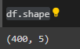
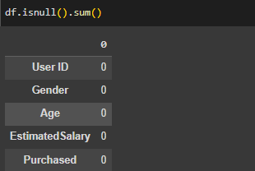

- Dropping Columns
df.drop(columns=['User ID','Gender'],axis=0,inplace=True)
df.describe()
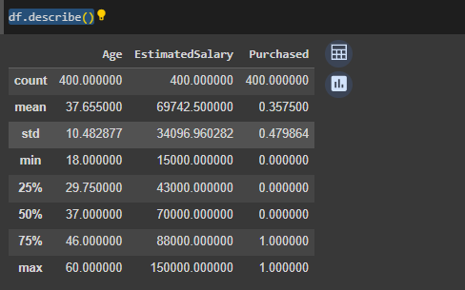

- Performing Normalization and Standardization

std=StandardScaler()
norm=MinMaxScaler()

df[['std_age','std_salary']]=std.fit_transform(df.iloc[:,0:2])
df[['norm_age','norm_salary']]=norm.fit_transform(df.iloc[:,0:2])
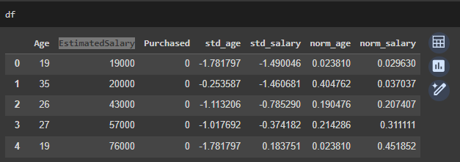

plt.scatter(df['Age'],df['std_salary'])
plt.xlabel('Age')
plt.ylabel('salary')
plt.title("Original data")

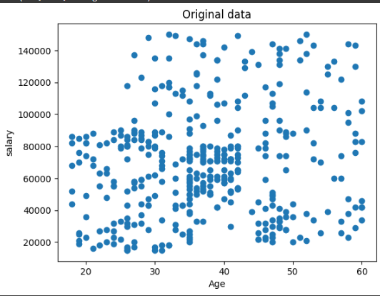

plt.scatter(df['std_age'],df['EstimatedSalary'])
plt.xlabel('Age')
plt.ylabel('salary')
plt.title("after standardization")
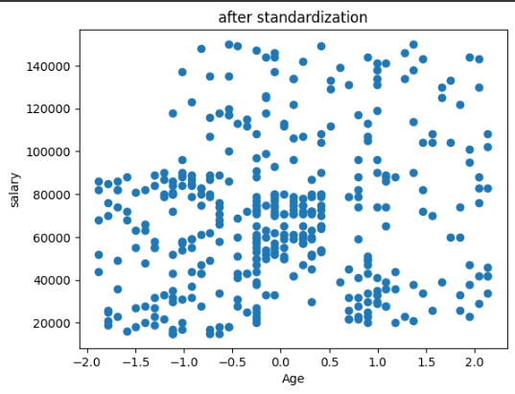

plt.scatter(df['norm_age'],df['norm_salary'])
plt.xlabel('Age')
plt.ylabel('salary')
plt.title("after normalization ")
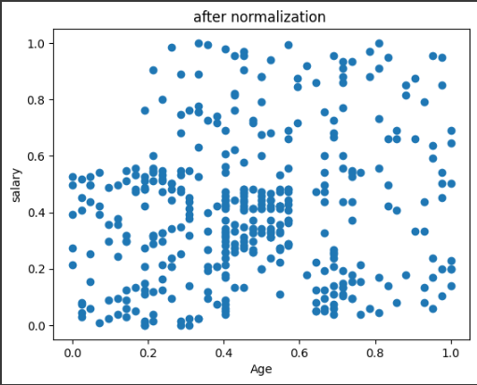
1.4 Feature Selection

import pandas as pd
from sklearn.datasets import load_diabetes
import seaborn as sns

data=load_diabetes()

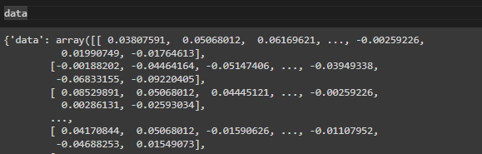

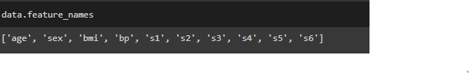
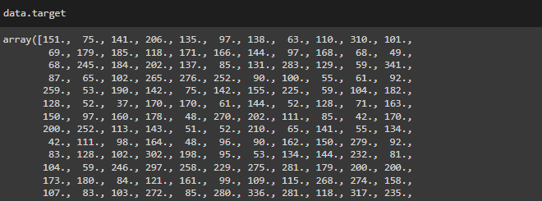

- Creating dataframe

ind=data.data
dep=data.target

x=pd.DataFrame(ind,columns=data.feature_names)
y=pd.DataFrame(dep,columns=['target'])
df=pd.concat([x,y],axis=1)

df.corr()
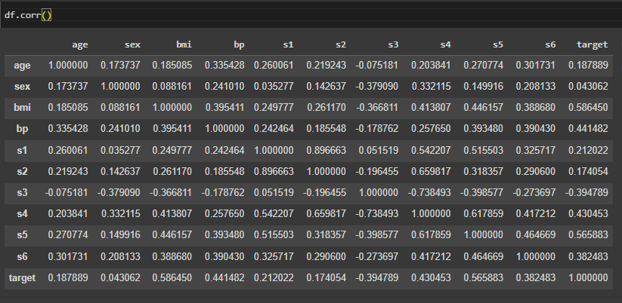

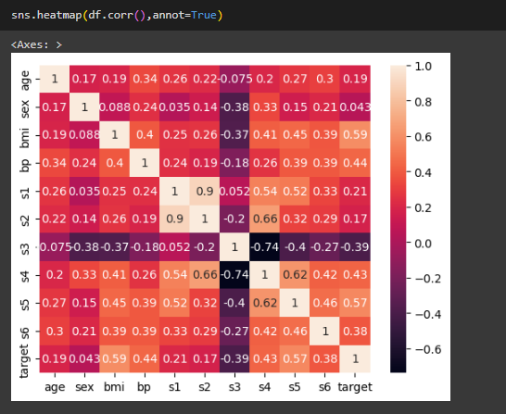

Practical 2
Linear Regression

2.1 Simple Linear Regression

import pandas as pd
import matplotlib.pyplot as plt
import seaborn as sns
from sklearn.preprocessing import StandardScaler,MinMaxScaler
import numpy as np

df = pd.read_csv('/content/drive/MyDrive/supervisedlearning/datasets /IceCreamData.csv')

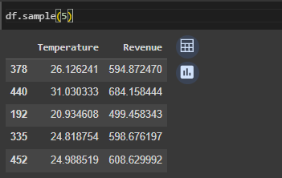
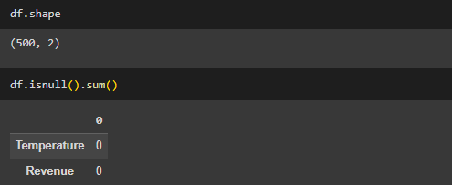
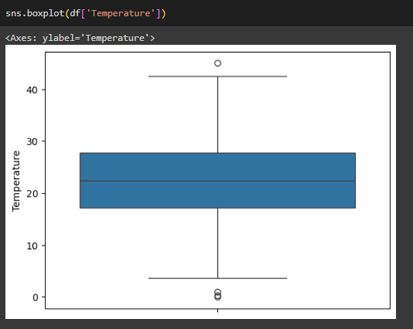

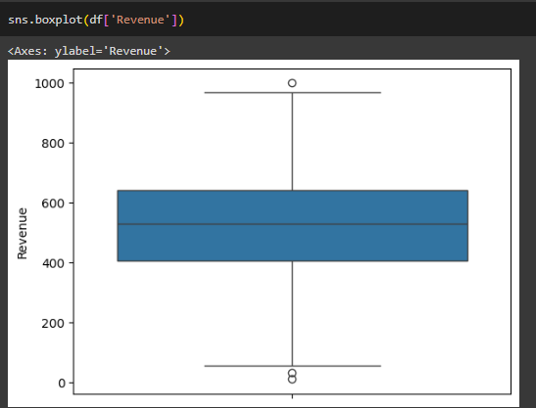

df.corr()
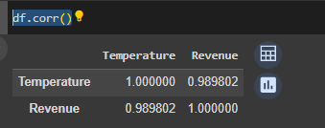

df['xi-bar']=df['Temperature']-df['Temperature'].mean()
df['yi-bar']=df['Revenue']-df['Revenue'].mean()
df['AxB']=df['xi-bar']*df['yi-bar']
df['xi-bar-sq']=np.square(df['xi-bar'])

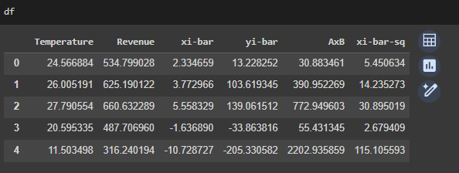
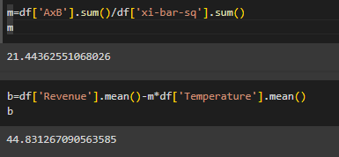
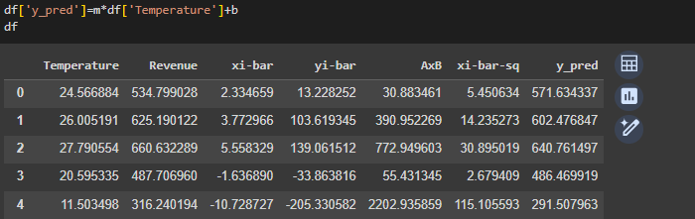

- Linear Regression model

from sklearn.linear_model import LinearRegression
from sklearn.model_selection import train_test_split
from sklearn.metrics import mean_absolute_error,mean_squared_error,accuracy_score

mse=mean_squared_error(df['Temperature'],df['y_pred'])
mae=mean_absolute_error(df['Temperature'],df['y_pred'])
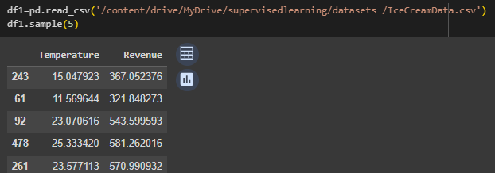

x_train,x_test,y_train,y_test = train_test_split(df1.drop('Revenue',axis=1),df1['Revenue'],test_size=0.3,random_state=42)

lr=LinearRegression()
lr.fit(x_train,y_train)
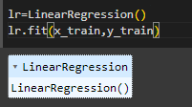

y_pred=lr.predict(x_test)
y_test.shape

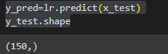

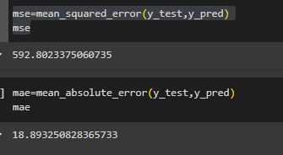

plt.scatter(df['Temperature'],df['Revenue'],color='blue',label='Actual data ')
plt.plot(x_test,y_pred,color='red',linewidth=2)
plt.xlabel('Temperature')
plt.ylabel('Revenue')
plt.title('Linear Regression')
plt.legend()
plt.show()

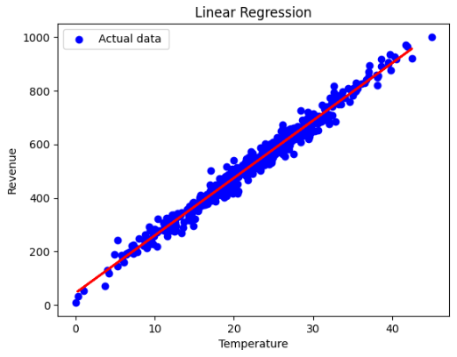

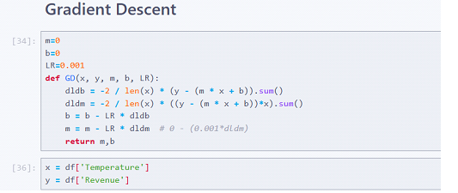
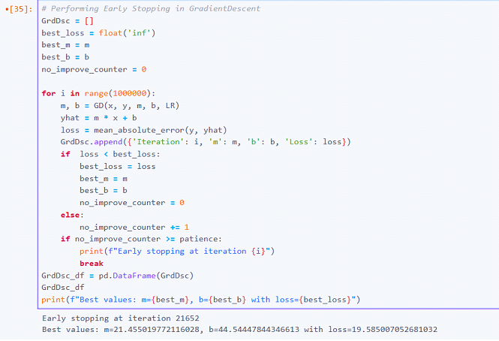

2.2 Multiple Linear Regression

import pandas as pd
import numpy as np
from sklearn.model_selection import train_test_split
from sklearn.linear_model import LinearRegression
from sklearn.metrics import mean_absolute_error,mean_squared_error,r2_score
import sklearn.metrics as metrics

df=pd.read_csv('/content/drive/MyDrive/supervisedlearning/datasets /Admission.csv')
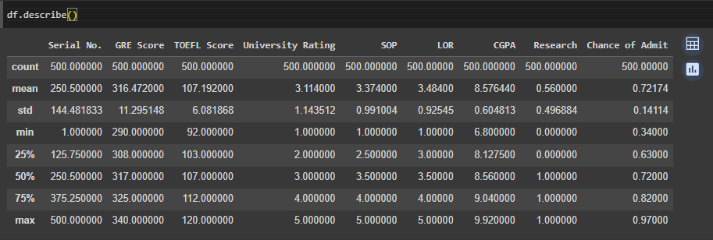

df.drop('Serial No.',axis=1, inplace=True)
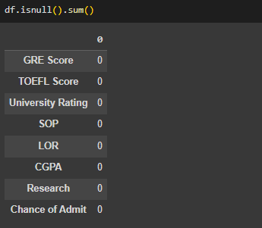
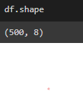
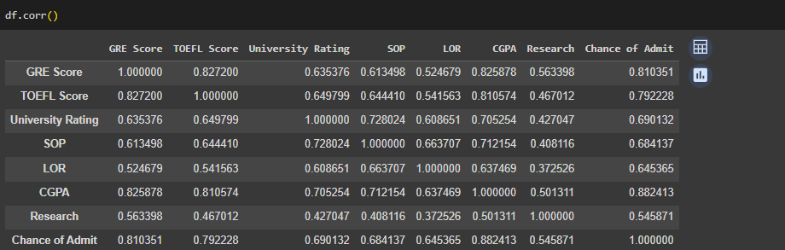

x_train,x_test,y_train,y_test=train_test_split(df.drop('Chance of Admit',axis=1),df['Chance of Admit'],test_size=0.3,random_state=42)

lr=LinearRegression()
lr.fit(x_train,y_train)

#beta values m
lr.coef_

#intercept value
lr.intercept_


y_pred=lr.predict(x_test)
mse=mean_squared_error(y_test,y_pred)
mae=mean_absolute_error(y_test,y_pred)
print(mse)
print(mae)
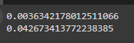

rmse=np.sqrt(mse)
r2 = metrics.r2_score(y_test,y_pred)
print(rmse)
print(r2)
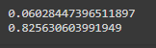
2.3 Polynomial Linear Regression

import pandas as pd
import numpy as np
import matplotlib.pyplot as plt
from sklearn.preprocessing import PolynomialFeatures
from sklearn.model_selection import train_test_split
from sklearn.linear_model import LinearRegression
from sklearn.metrics import mean_absolute_error,mean_squared_error
import sklearn.metrics as metrics

df=pd.read_csv('/content/drive/MyDrive/supervisedlearning/datasets /PolyData.csv')
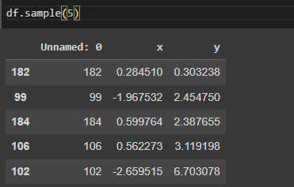

df.drop('Unnamed: 0',axis=1,inplace=True)
plt.scatter(df['x'],df['y'])
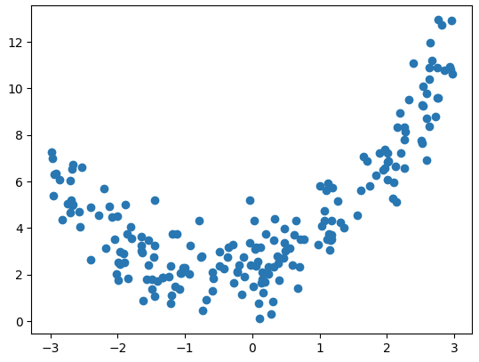

x_train,x_test,y_train,y_test=train_test_split(df.drop('y',axis=1),df['y'],test_size=0.3,random_state=42)
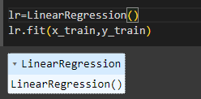

lr.coef_y_pred=lr.predict(x_test)
plt.scatter(df['x'],df['y'],color='blue',label='Actual data')
plt.plot(x_test,y_pred, color='red',linewidth=2,label='reggresion liine ')
plt.xlabel('x')
plt.ylabel('y')
plt.title("regression line on actual data")
plt.legend()
plt.show()
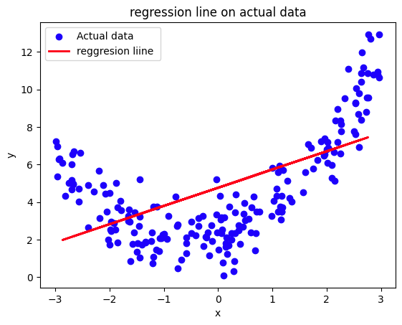

y_pred=lr.predict(x_test)
mse=mean_squared_error(y_test,y_pred)
mae=mean_absolute_error(y_test,y_pred)
rmse=np.sqrt(mse)
r2=metrics.r2_score(y_test,y_pred)
print(mse)
print(mae)
print(rmse)
print(r2)

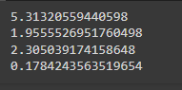

- creating polynomial feature

x=df['x'].values.reshape(-1,1)
y=df['y'].values.reshape(-1,1)
poly=PolynomialFeatures(degree=3)
x_poly=poly.fit_transform(x)
x_poly
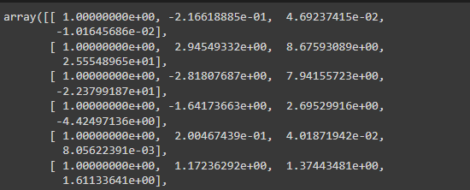

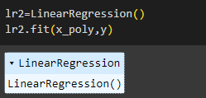

x_range=np.linspace(min(x),max(x),len(x))
plt.scatter(x,y)
plt.plot(x_range,lr2.predict(poly.fit_transform(x_range.reshape(-1,1))),color='red')
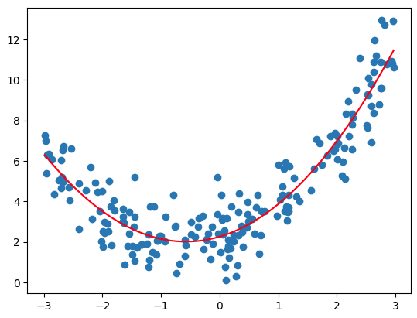

Practical 3
Regularization

import pandas as pd
import numpy as np
import seaborn as sns
import matplotlib.pyplot as plt
from sklearn.linear_model import LinearRegression
from sklearn.model_selection import train_test_split
from sklearn.metrics import accuracy_score,mean_absolute_error,r2_score
import sklearn.metrics as metrics
from sklearn.linear_model import Ridge,Lasso
import warnings
warnings.filterwarnings('ignore')
import plotly.express as px

df=pd.read_csv('/content/drive/MyDrive/supervisedlearning/datasets /Advertising.csv')

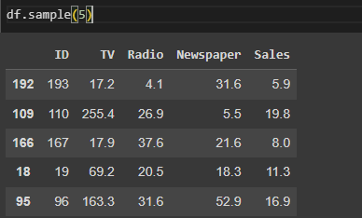

df.drop('ID',axis=1,inplace=True)

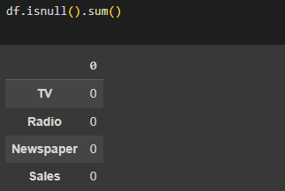
x_train,x_test,y_train,y_test=train_test_split(df.drop('Sales',axis=1),df['Sales'],test_size=0.3,random_state=42)

px.scatter_3d(df,x='TV',y='Radio',z='Newspaper')
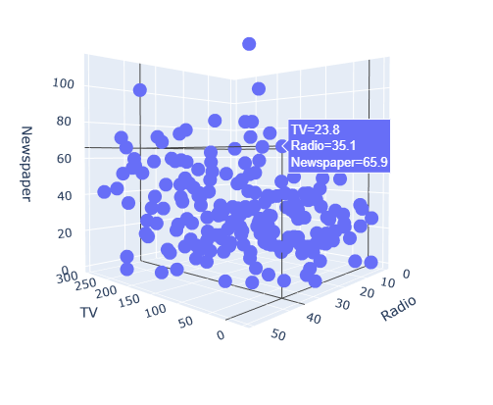

lr=LinearRegression()
lr.fit(x_train,y_train)
y_pred=lr.predict(x_test)

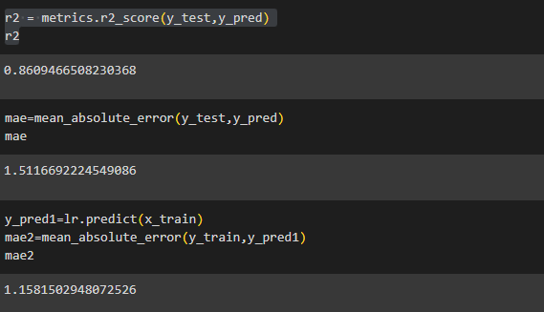

3.1 L2 regularization ridge regression

rg=Ridge(alpha=3)
rg.fit(x_train,y_train)
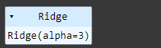

rg_pred=rg.predict(x_test)
r2=metrics.r2_score(y_test,rg_pred)
r2



alpha=[0,2000,4000,6000,8000]
for i in alpha:
rg=Ridge(alpha=i)
rg.fit(x_train,y_train)
print(f'alpha:{i},parameter of b1,b2,b3:{rg.coef_},accuracy:{r2_score(y_test,rg.predict(x_test))}')

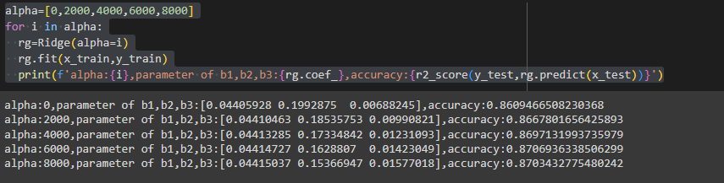

3.2 L1 regularization Lasso regression

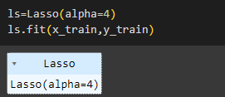

ls_pred=ls.predict(x_test)
r2 = metrics.r2_score(y_test,ls_pred)
r2
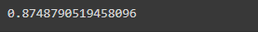

alpha=[1,3,5,6,8,0,7]
for i in alpha:
ls=Lasso(alpha=i)
ls.fit(x_train,y_train)
print(f'alpha:{i},parameter of b1,b2,b3:{ls.coef_},accuracy:{r2_score(y_test,ls.predict(x_test))}')
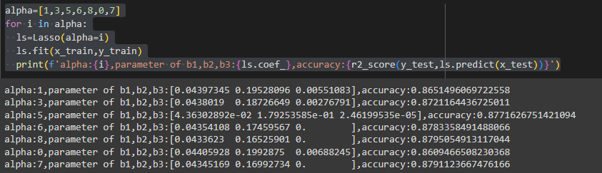

Practical 4
Classification

4.1 Logistic Regression

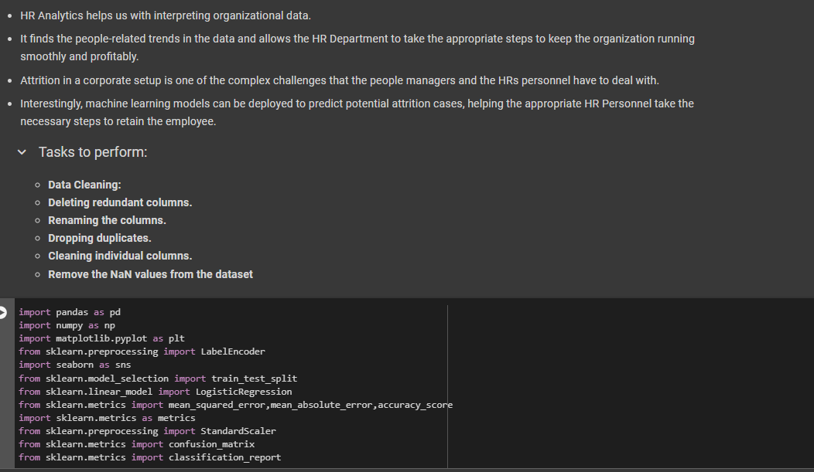

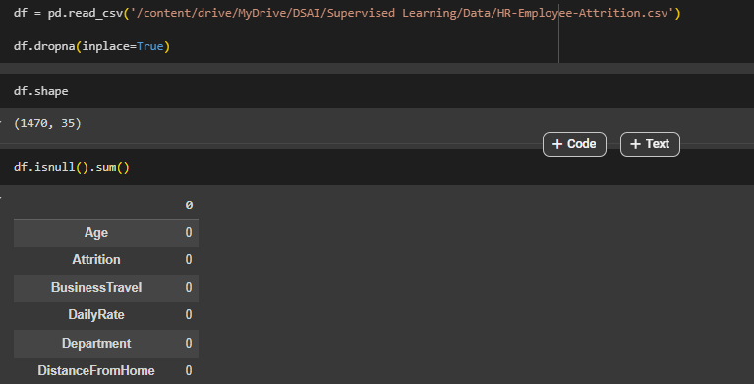

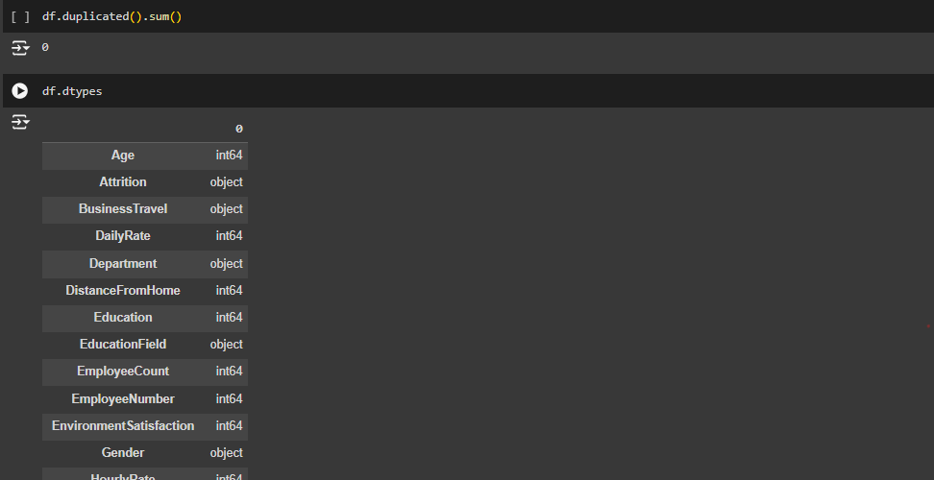

Converting all the Object columns to Numeric (int) as for correlation we need numeric values.

- Performing Label Encoding

categorical_columns = [col for col in df.columns if
df[col].dtype == 'object']
print(categorical_columns)
for i in categorical_columns:
print(df[i].unique())
le = LabelEncoder()
for i in categorical_columns:
df[i]=le.fit_transform(df[i])
df
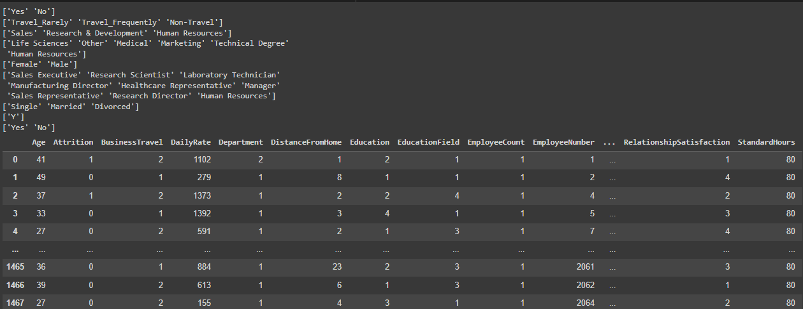

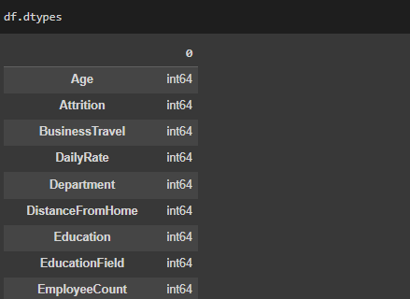

df.corr()

plt.figure(figsize=(30, 20))
sns.heatmap(df.corr(),fmt='.2f',annot=True)
plt.title('Correlation Heatmap')
plt.show()
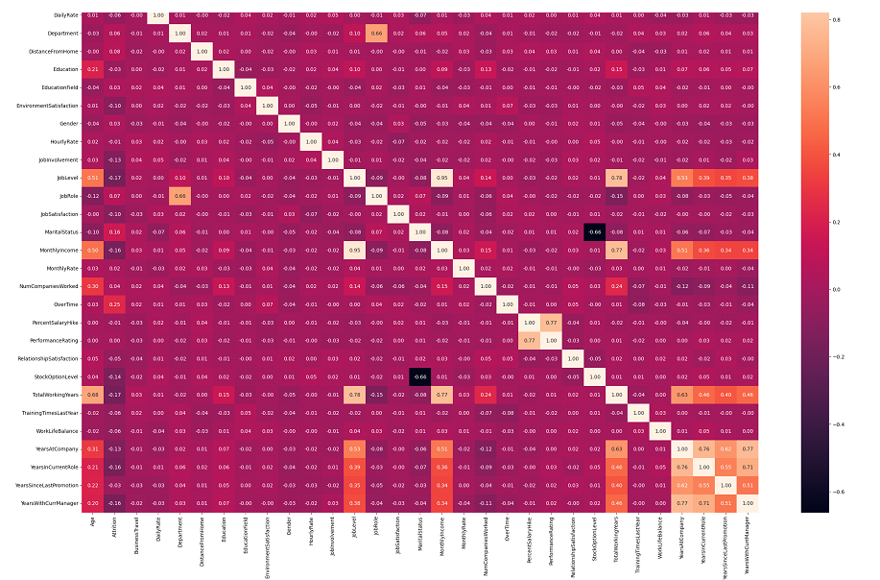

df.drop(['EmployeeCount', 'EmployeeNumber', 'Over18', 'StandardHours'], axis=1, inplace=True)

To address multicollinearity, features with a correlation coefficient greater than 0.75 will be identified. These highly correlated features will then be compared to determine which ones exhibit stronger correlations with each other rather than with the target variable, Attrition.
cm = df.corr()

# Create a mask to identify the features with a correlation coefficient greater than or equal to 0.75
high_correlation_columns = cm >= 0.75
highly_correlated_features = []

for feature in high_correlation_columns.columns:
correlated_with =
high_correlation_columns.index[high_correlation_columns[feature]].tolist()
for correlated_feature in correlated_with:
if feature != correlated_feature and (correlated_feature, feature) not in highly_correlated_features:
highly_correlated_features.append((feature, correlated_feature))

print("Highly correlated features:")
for feature1, feature2 in highly_correlated_features:
print(f"{feature1} and {feature2}")
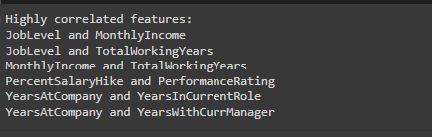

By observation, we will drop those columns that are not likely to contribute more in outcome.

# droping columns which are highly correlated
df1=df
cols = ["JobLevel", "TotalWorkingYears", "PercentSalaryHike", "YearsInCurrentRole", "YearsWithCurrManager"]
df1.drop(columns=cols,axis=1, inplace=True)
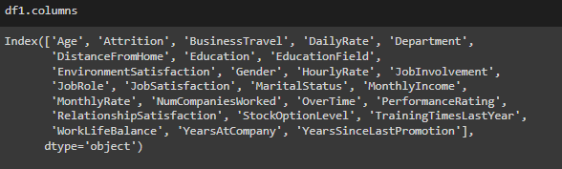

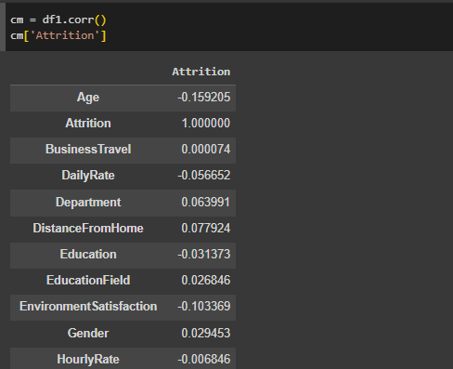

negative_corr=[]
negative_corr= cm['Attrition'][cm['Attrition'] < 0]
#df=df.drop(negative_corr, axis=1, inplace=True)
deletecolumns= negative_corr.index.tolist()
deletecolumns
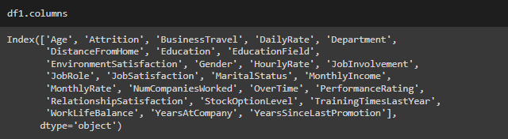
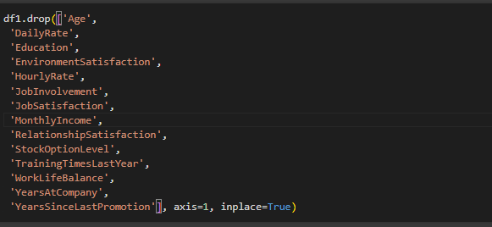
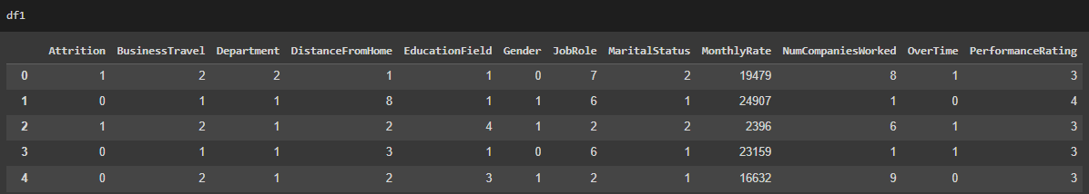

X = df1.drop('Attrition', axis=1)
y = df1['Attrition']

X_train, X_test, y_train, y_test = train_test_split(X, y, test_size=0.2, random_state=42)
model = LogisticRegression()
model.fit(X_train, y_train)
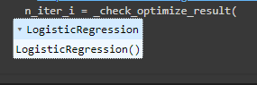

y_pred = model.predict(X_test)
print("Confusion Matrix:")
print(confusion_matrix(y_test, y_pred))
print("\nClassification Report:")
print(classification_report(y_test, y_pred))
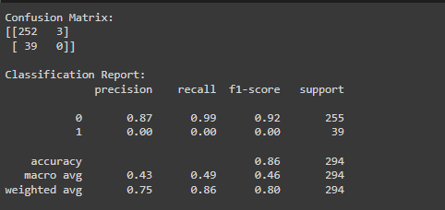

- Performing SMOTE Analysis

import imblearn
from imblearn.over_sampling import SMOTE
smote = SMOTE()
x_smote, y_smote = smote.fit_resample(X, y)
print("Before Smoote" , y.value_counts())
print()
print("After Smoote" , y_smote.value_counts())
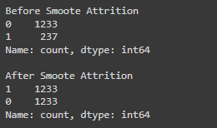

X_train, X_test, y_train, y_test = train_test_split(X_smote, y_smote, test_size=0.2, random_state=42)

scaler = StandardScaler()
X_train_scaled = scaler.fit_transform(X_train)
X_test_scaled = scaler.transform(X_test)

LR = LogisticRegression()
LR.fit(X_train_scaled, y_train)

y_pred = model.predict(X_test_scaled)

print("Confusion Matrix:")
print(confusion_matrix(y_test, y_pred))

print("\nClassification Report:")
print(classification_report(y_test, y_pred))
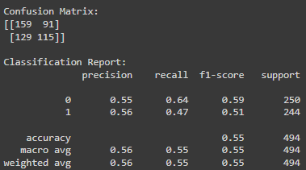

4.2 Decision Tree
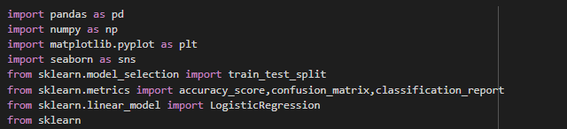
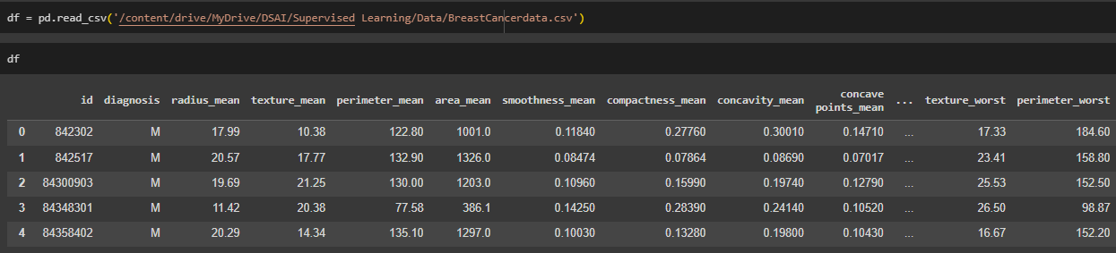

from sklearn.preprocessing import LabelEncoder
le = LabelEncoder()
df['diagnosis'] = le.fit_transform(df['diagnosis'])

df.drop('id','Unnamed: 32',axis=1,inplace=True)

df.corr()
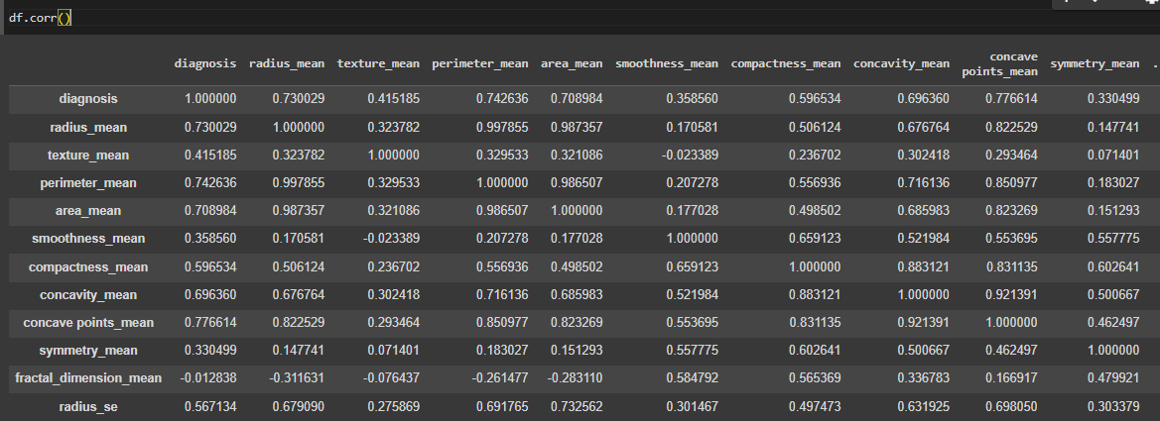

Xtrain,Xtest,Ytrain,Ytest = train_test_split(df.drop('diagnosis',axis=1),df['diagnosis'],test_size=0.2,random_state=42)

from sklearn.tree import DecisionTreeClassifier
dt = DecisionTreeClassifier()
dt.fit(Xtrain,Ytrain)
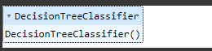

y_pred=dt.predict(Xtest)
accuracy = accuracy_score(Ytest,y_pred)
accuracy
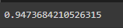

cm = confusion_matrix(Ytest,y_pred)
cm
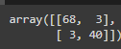

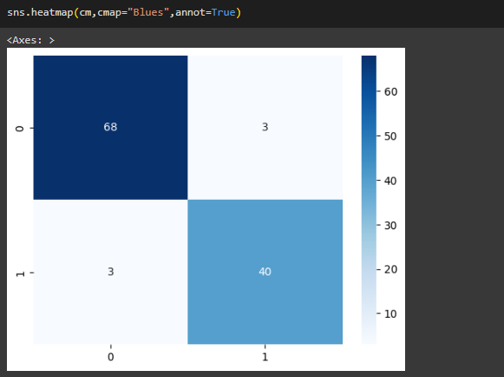

cf= classification_report(Ytest,y_pred)
print(cf)
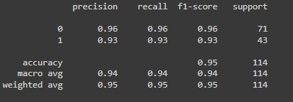
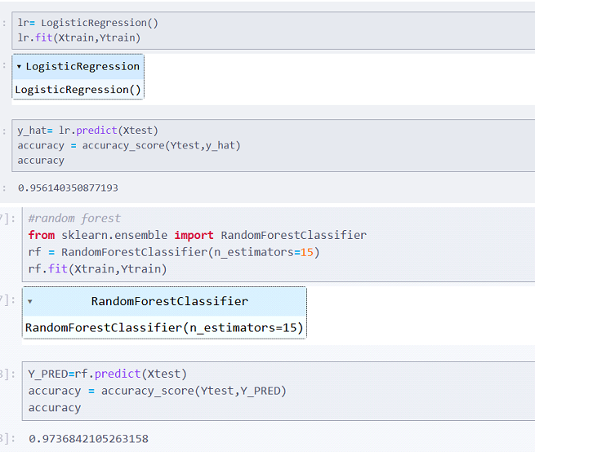

4.3 Random Forest

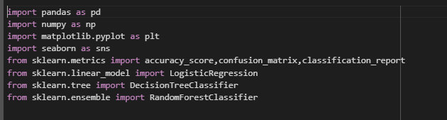

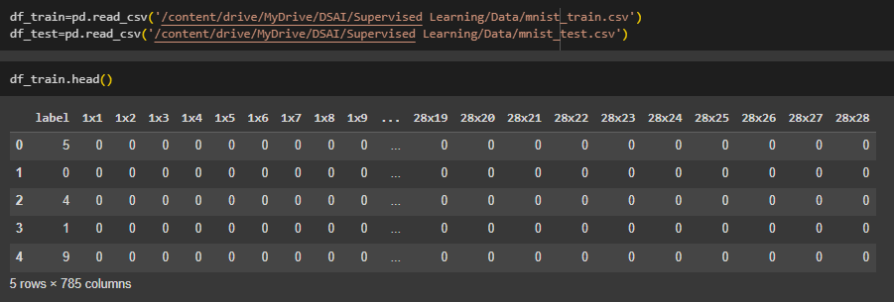

rf=RandomForestClassifier(n_estimators=150)
x_train=df_train.drop('label',axis=1)
y_train=df_train['label']
rf.fit(x_train,y_train)

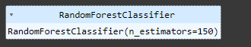

x_test=df_test.drop('label',axis=1)
y_test=df_test['label']
y_pred = rf.predict(x_test)

accuarcy=accuracy_score(y_test,y_pred)
accuarcy
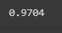

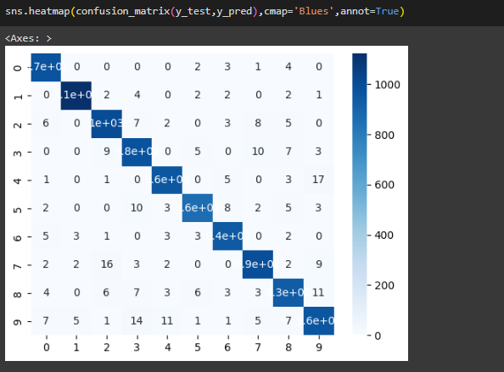

for i in range(0,5):
pixel = df_train.iloc[i,1:].values.reshape(28,28)
plt.imshow(pixel,cmap='gray')
plt.title(df_train.iloc[i,0])
plt.show()
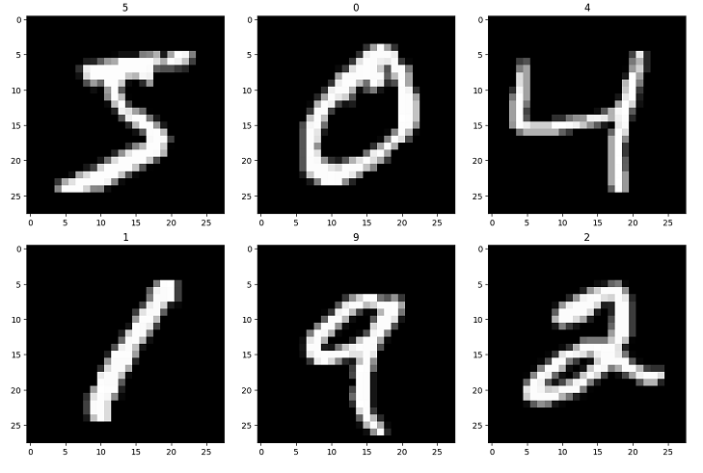
4.4 Naive Bayes

import pandas as pd
import re
import seaborn as sns
import matplotlib.pyplot as plt
from nltk.corpus import stopwords
from nltk.tokenize import word_tokenize
from nltk.stem import PorterStemmer
from sklearn.model_selection import train_test_split
from sklearn.naive_bayes import MultinomialNB
from sklearn.feature_extraction.text import CountVectorizer
from sklearn.metrics import accuracy_score,confusion_matrix,classification_report
import nltk
nltk.download('stopwords')
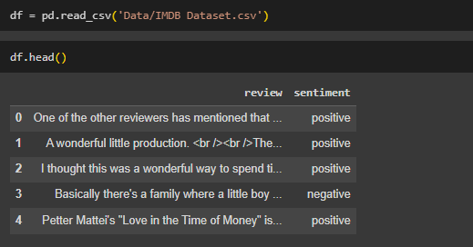

df['review'].iloc[2]
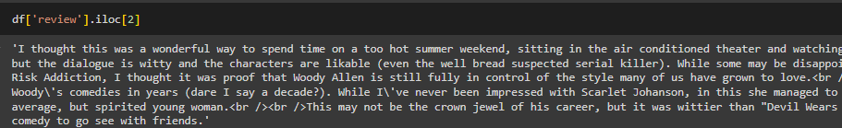

df['sentiment'] = df['sentiment'].replace({'positive': 1, 'negative': 0})

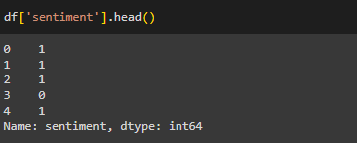

clean = re.compile('<.*?>')
df['review'] = df['review'].apply(lambda x: re.sub(clean, '', x))
df['review'] = df['review'].str.lower()
df['review'] = df['review'].str.replace(r'[^\w\s]', ' ', regex=True) # Removing Punctuation and Non-Alphanumeric Characters
df['review'] = df['review'].str.replace(r'\s+', ' ', regex=True).str.strip() # Removing Extra Whitespace
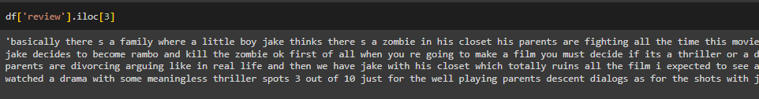

- Removing stop words

st = set(stopwords.words('english'))
df['review'] = df['review'].apply(lambda x: ' '.join([word for word in x.split() if word not in st]))

- Stemming

porter = PorterStemmer()
df['review'] = df['review'].apply(lambda x: ' '.join([porter.stem(word) for word in word_tokenize(x)]))

- Vectorization
vect = CountVectorizer()
X = vect.fit_transform(df['review'])

X_train, X_test, y_train, y_test = train_test_split(X, df['sentiment'], test_size=0.2, random_state=42)

- Naive Bayes model

nb = MultinomialNB()
nb.fit(X_train, y_train)
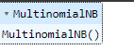

y_pred = nb.predict(X_test)
accuracy = accuracy_score(y_test, y_pred)
conf_matrix = confusion_matrix(y_test, y_pred)
class_report = classification_report(y_test, y_pred)

print(f'Accuracy: {accuracy}')
print('Confusion Matrix:\n', conf_matrix)
print('Classification Report:\n', class_report)
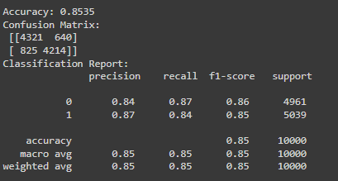

sns.heatmap(conf_matrix, annot=True, fmt='d', cmap='Blues',
xticklabels=['Negative', 'Positive'],
yticklabels=['Negative', 'Positive'])
plt.xlabel('Predicted Label')
plt.ylabel('True Label')
plt.title('Confusion Matrix')

